Speyside Fields for Wildlife 2025 Report
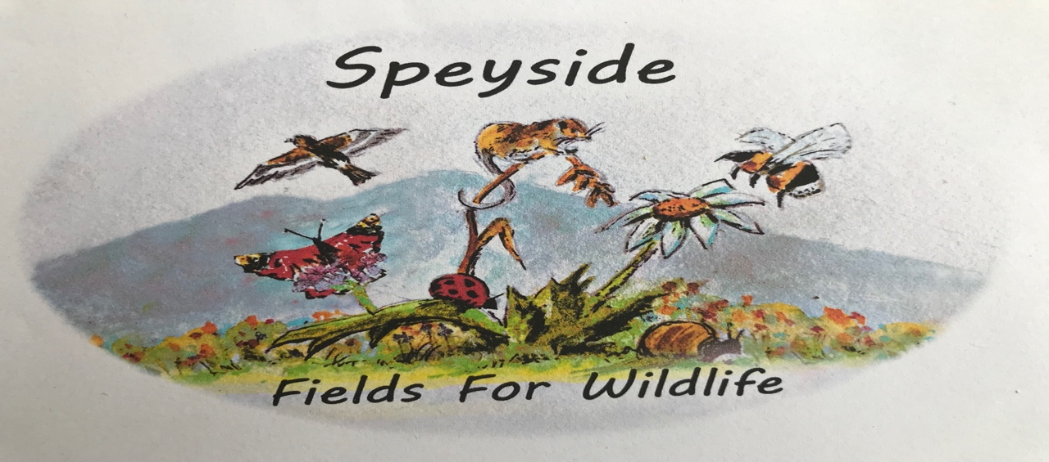
This was our ninth season of working with farmers and other landowners to create flower meadows or to improve sites for wildlife. It was quite a season, with the longest, hottest and driest summer on record! With hardly any rain during April, May and June, we worried that our expensive seeds would perish. Thankfully, there was just enough rain to get them established and as summer progressed, most bloomed well.
We held our open day on 23rdof July and visited a few local sites on a fine afternoon, finishing up in Keith and Aileen’s beautiful garden for afternoon tea.
Aileen organised a couple of work parties to assist at Castle Roy, so thanks to these volunteers who gave of their time.
Thanks also to our small steering group and to the local farmers and contractors who undertook ground prep or cut and cleared toppings in the autumn.
Special thanks to our patrons and to private donations from supporters and to the CNPA without whose financial support, we would not be able to create these magical meadows.
We have been awarded grants for specific projects from The Cairngorms Trust and Moraycan in 2025 which is greatly appreciated.
Here is a short account of some of the sites from the 2025/26 season.

Broomhill Court Nethybridge
This small paddock was in its second season and was interesting in that it had two flushes of flowers. In early summer, thanks to good strimming work by local resident Richard Revill, lots of orange and yellow hawkweeds appeared along with several northern marsh orchids. As summer progressed, the sown perennial meadow developed well and was mown in late September by Gerald Calder.
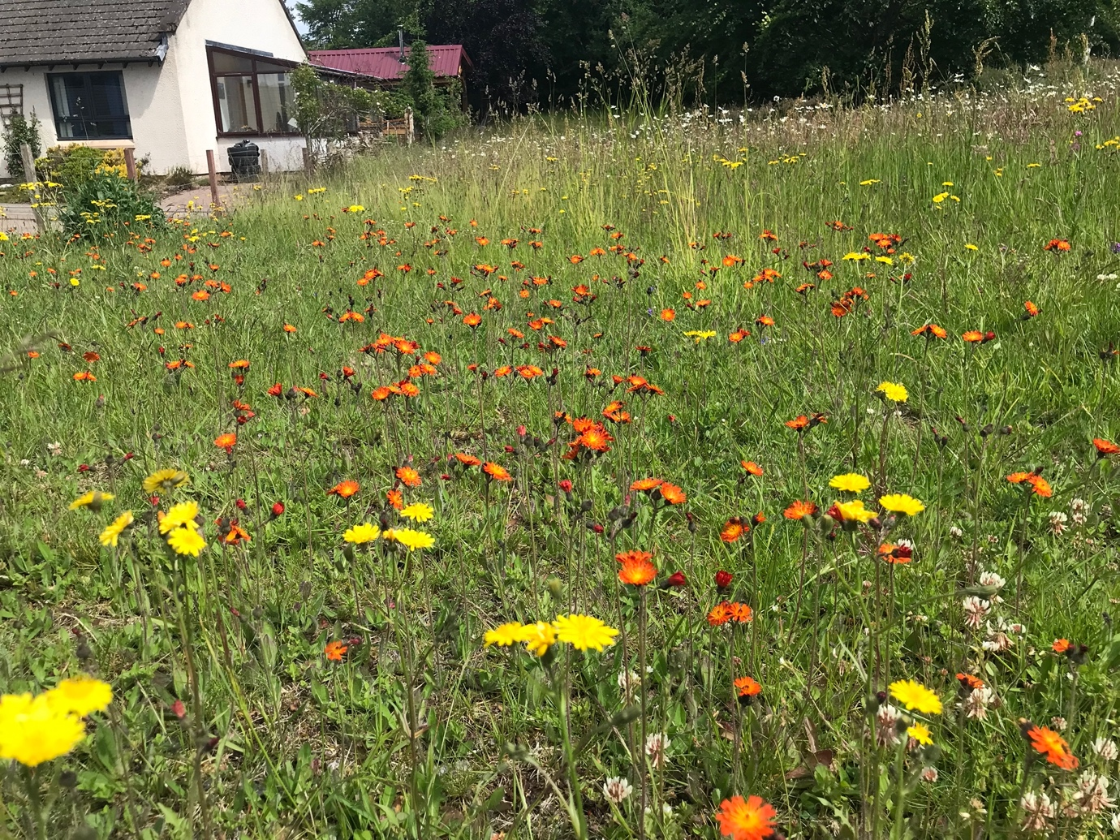
Broom hill Court meadow on 15th June; lots of fox and cubs.

Dellifure Natural Burial Ground Cromdale
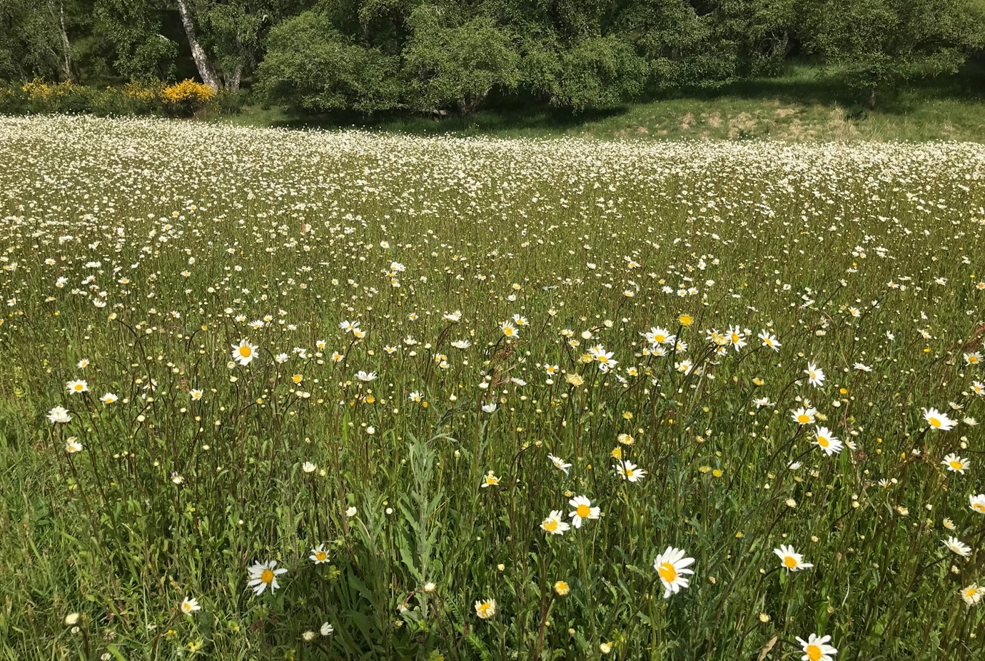
Dellifure on 7th June
Now in its fourth season, it has established well but rather dominated by white oxe-eye daisies. Dellifure (Leedham) has won a ‘Networks for Nature’ Grant from the CNPA, so next season we plan to assist them in creating another three small meadows alongside the main access track to the burial ground. These will be of native seeds purchased from Scotia Seeds in Brechin. During the winter moles have been busy, and hundreds of mole hills have appeared in the fields. We plan to sprinkle some flower seeds in these earth mounds next spring.

Easter Tulloch three sites totalling 3.5 ha
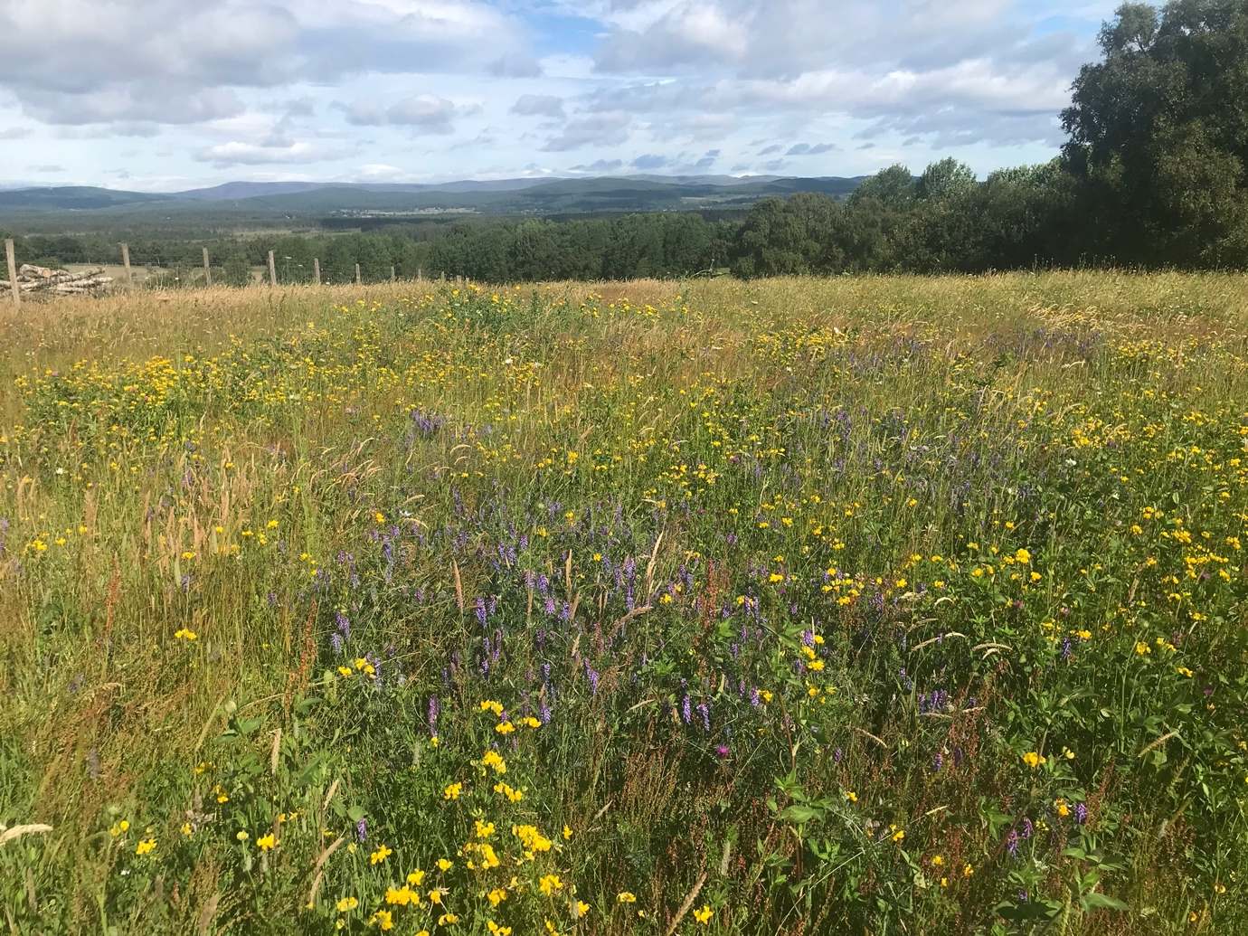
Perennial meadow on 10th July
Three separate fields this year at Easter Tulloch:
The perennial meadow established in 2020, a small corn annual meadow and a larger 2 ha wild bird seed field established this year.
Despite the summer drought they did well and provided a massive source of pollen and nectar for a wide range of bees, butterflies and other insects throughout the summer.
By the end of October there were several hundred finches already feeding in the Wild Bird Seed field.
The local red and roe deer also enjoyed the tasty easy pickings. By mid-October, bird numbers began to build up and on 17th November ca. 1500 finches were using the WBS crop. Most were chaffinches, but a few green and goldfinches plus a few linnets and an odd brambling. The tall quinoa seemed to be a favourite food source. On 2nd December I estimated the flock to be around 2000! This is the largest finch flock we have had in any of our WBS fields. By Christmas, they had eaten most of the seed and the flock was down to a few hundred.
Checkout our Instagram gallery for a short video of the finch flock on Dec 3rd.
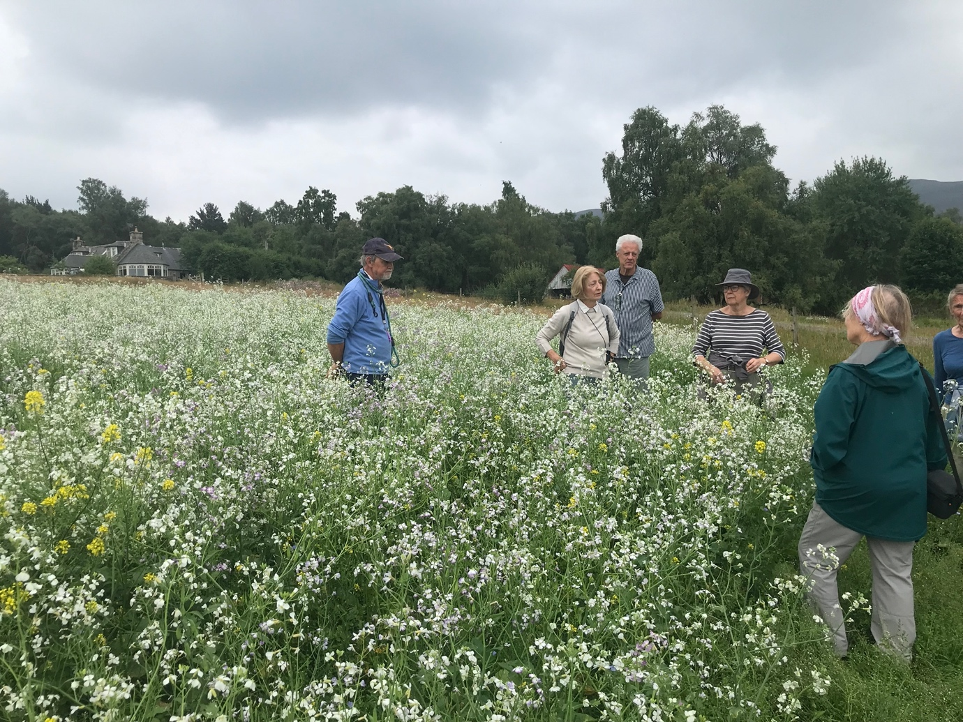
Viewing the Easter Tulloch bird seed crop on 23rd July. Keith, Aileen and Hamish hand sowed this on 31st May.
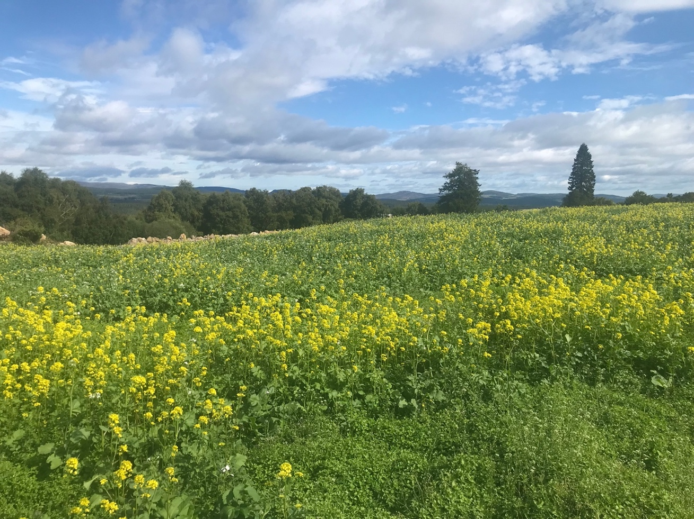
Birdseed crop on 10th July

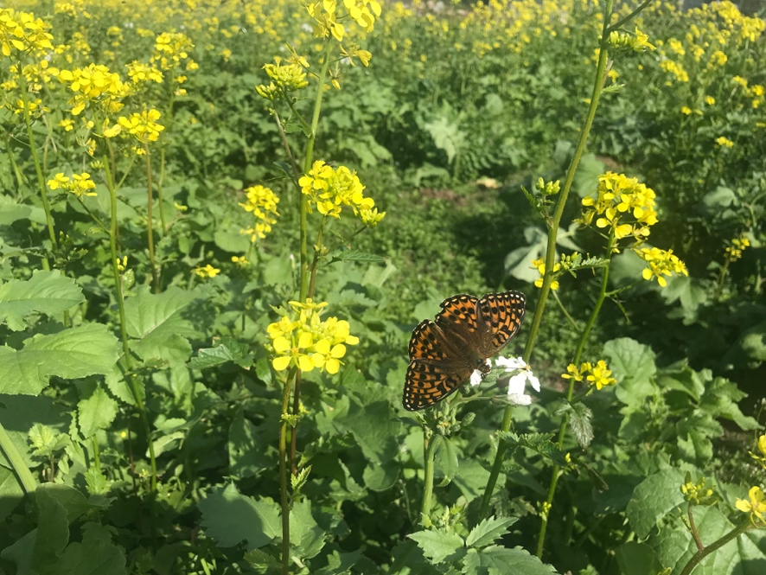
Dark green fritillary on birdseed crop at Easter Tulloch 10th July
The Tulloch area has some of the most extensive aspen stands in UK but sadly during the winter storms, about 30 mature aspen trees were blown over at Easter Tulloch and Tontearie. In discussion with Bob Moncrieff who farms Easter Tulloch, we agreed to fence an area of rough ground adjacent to the woodland where lots of aspen suckers were regularly being browsed by stock.
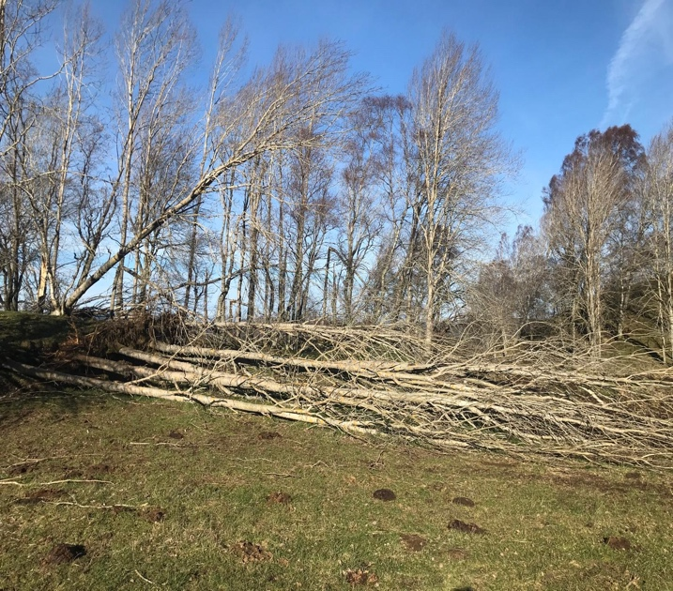
Some of the aspens blown down in the recent gales.
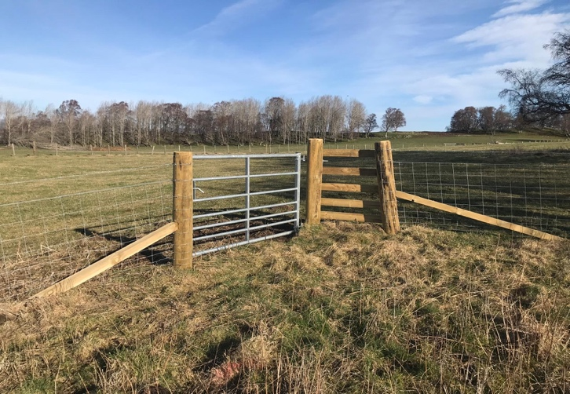
140 m of new stock fence was erected by local contractor James Smith. Since aspen is a priority species within the National Park, CNPA kindly funded this work.
Caledon 2 ha perennial meadow
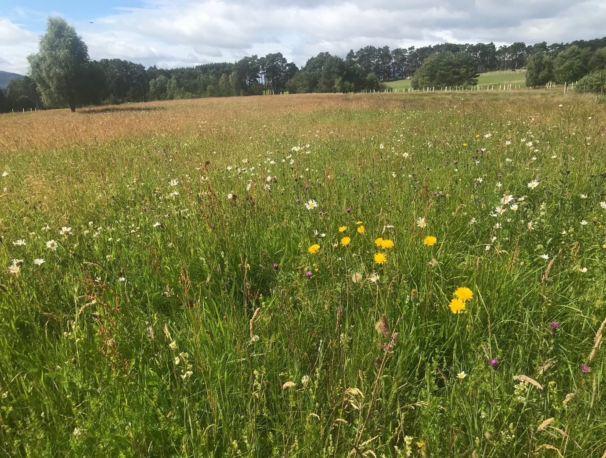
Photo 10th July
With our light sandy soil, the dry summer weather was not the best for our meadow. Lots of ox-eye daisy and yellow rattle with a few mallows. We had lots of orchids which were probably indigenous stock. Butterflies this year were excellent with an abundance of tortoiseshell and peacocks. During the season we had small pearl-bordered fritillary, meadow brown, Scots Argus, common blue , comma, and dark green fritillary. Sheep grazed the meadow for a few weeks in autumn.
Looking forward to what the coming season brings.
Stewart Potter.

Castle Roy
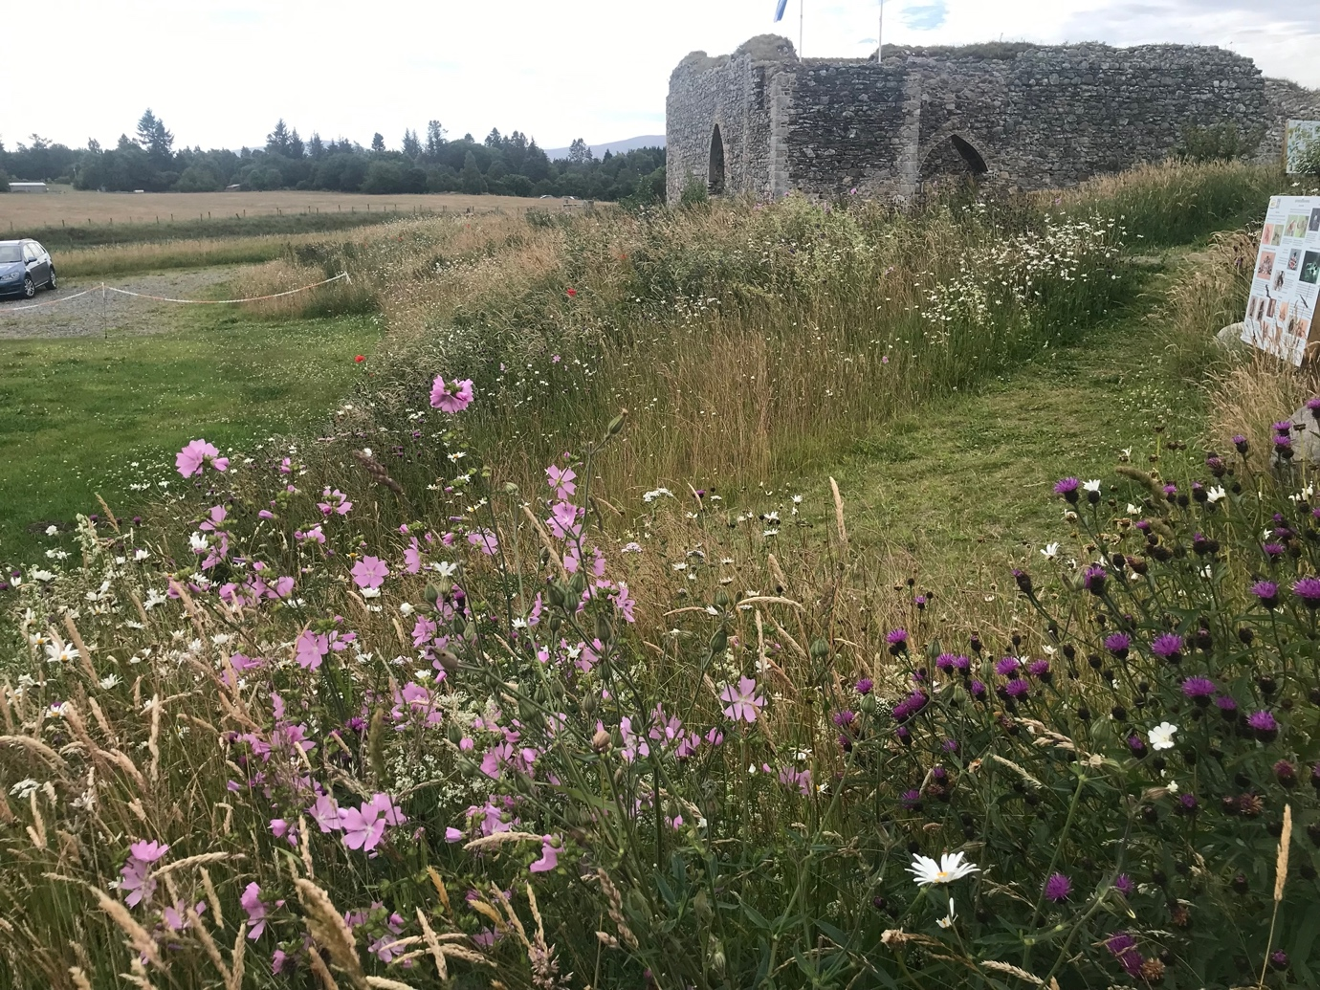
Castle Roy slightly past its best on 8th July
SFW began working with The Castle Roy Trust in 2021. The first perennial meadow areas are changing and developing well. With volunteer help we have been expanding the areas of wildflower through wildflower seeding, yellow rattle, some plug planting and through appropriate management. A new drum mower was purchased by The Castle Roy Trust with help from The Cairngorms Trust. In 2024 100metres of wildlife hedge was planted and this is establishing well. This year we have added some native species trees to the site. For the many visitors there are new information boards erected by the Castle Roy Trust. The CRT were also able to allow a few sheep to graze briefly on the motte and wildflower areas in December. Thanks to volunteers for their especially hard work at Castle Roy. 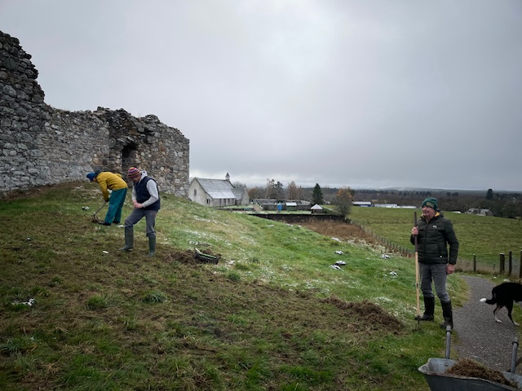

Clury 1 ha 4 small patches established 2024
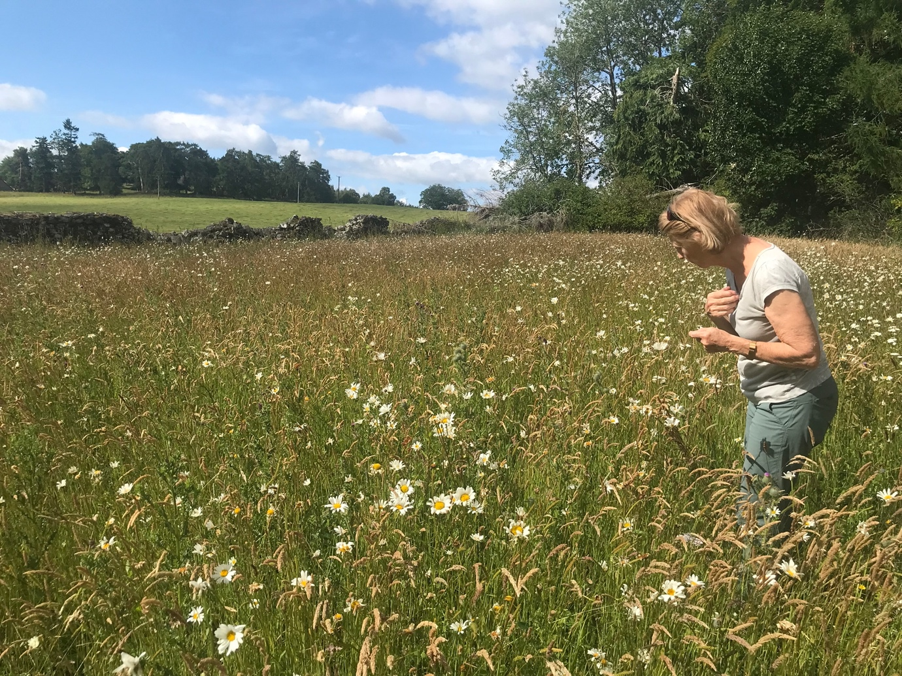
Aileen inspects one of the Clury meadows on 11th July
This is a newly sown meadow and as seems often the case is dominated in the first years with oxe-eye daisy. We hope with time and good management we should see more variety establishing in later years.

Glenbeg
This site has 4 or 5 acres of unfertilised grassland, native birch woodland and aspen woodland. SFW are encouraging flowering species to colonise the area through management. Part of the management requires some winter grazing and thanks to a Cairngorms Trust grant that can now go ahead. SFW have cut and baled the meadow for 2 years now and in 2025 we have disced two small areas for Scotia Seed wildflower and yellow rattle seeding. We have also supported the landowner with a small number of native tree plantings and the protection of aspen stands on the site. We have plans for non-native tree removal and re-planting with appropriate species.
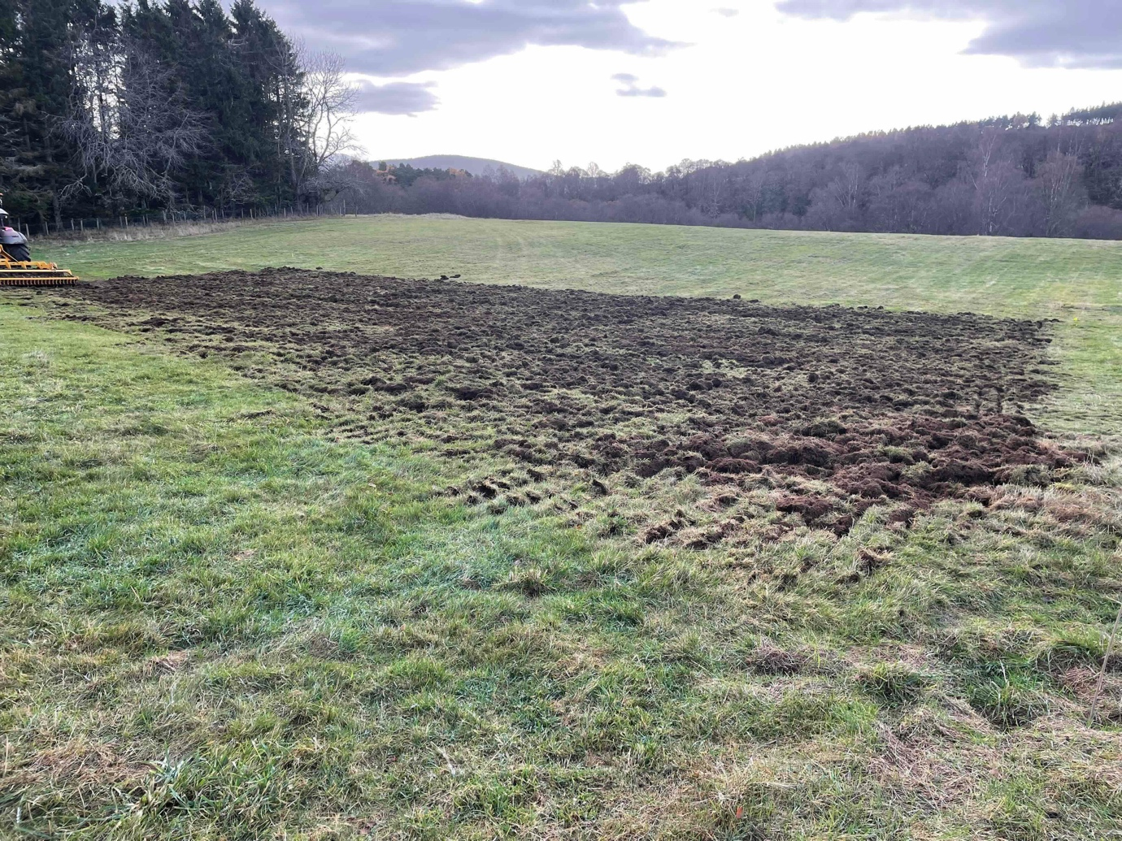
One of the newly disced areas at Glenbeg ready for sowing.

Mousa 0.5 ha hand sown on 5th May
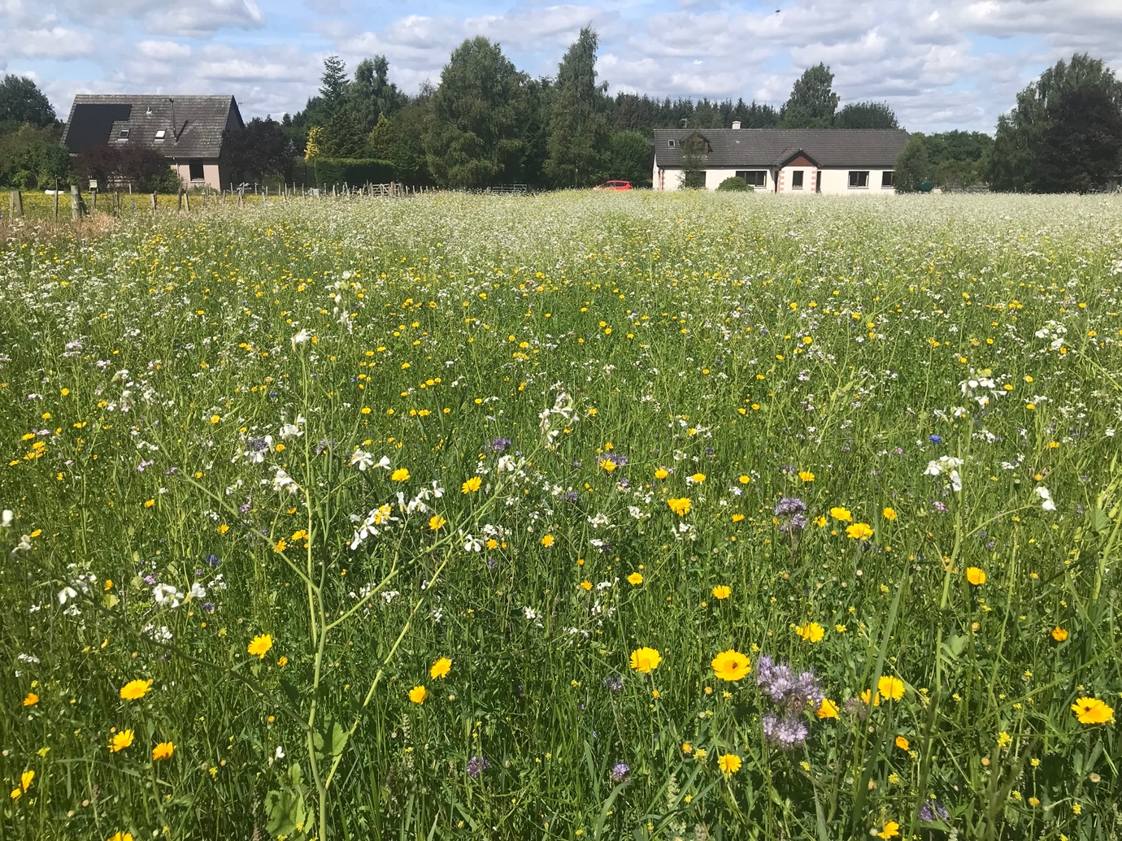
In full bloom on 11th July
This field has had a mix of corn annuals and WBS now for eight years. This year we tried to reduce the dominance of yellow corn marigold, but they have proved to be very persistent and came up again this year. It bloomed well despite the dry weather but went over quite quickly perhaps because of the excessive heat in early summer.

Kinakyle 0.5 acre hand sown on 3th May
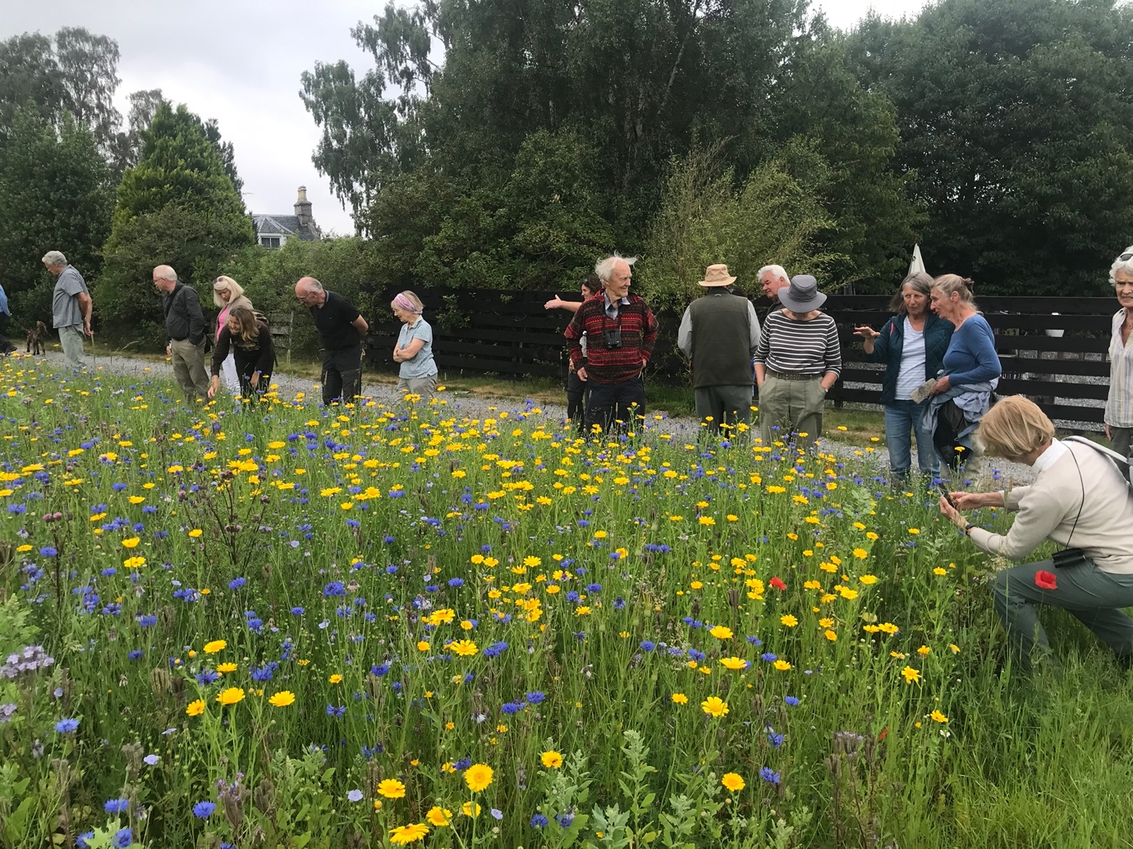
Our open afternoon at the Kinakyle meadow on 23rd July
Hand sown on the 3rd of May with corn annuals but also with some linseed and phacelia mixed in. What a show it gave, and looked its best when we visited on our open day towards the end of July.

Pityoulish 1h hand sown 31st May
This was a new site this season. Ground prep was undertaken by local farmer Donnie Black and Keith and Aileen sowed it at the end of May.
Like most sites it got stuck with the summer drought but by August it looked great. Watsons wild bird seed was sown in the middle and a strip of corn annuals with some phacelia and linseed was sown round the edges.
WBS was at its best towards the end of July, and the flowers gave a great show around mid-August. The image below was taken on 22nd of August and it was still flowering during the last days of October when ca. 300 finches were present.
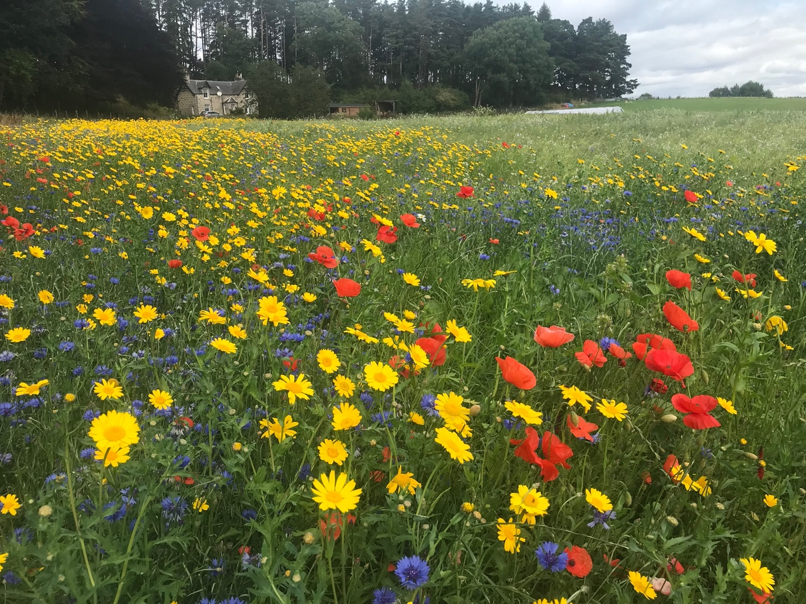
By mid-November ca. 500 finches were using the bird crop and on 21st November after a heavy snowfall, there were 5-600, mostly chaffinches but also linnets and a few goldfinches. At least one sparrowhawk was regularly present putting panic into the hungry birds. Best count was on 3rd December when the flock was estimated at 8-900.

